**PIZZA SALES SQL QUERIES**

**A. KPI’s**

**1. Total Revenue:**

select round(sum(total_price),2) as Total_Revenue

from pizza_sales;

***Output:***

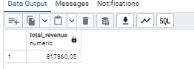

**2. Average Order Value**

select round( sum(total_price) / (select count(distinct order_id) from pizza_sales ) ,2) as avg_order_val

from pizza_sales;

***Output:***

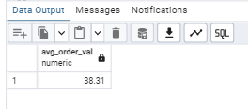

**3. Total Pizzas Sold**

select sum(quantity) as total_pizzas_sold

from pizza_sales;

***Output:***

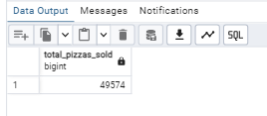

**4. Total Orders**

select count( distinct order_id) as total_orders

from pizza_sales

***Output:***

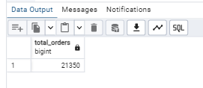

**5. Average Pizzas Per Order**

select round( sum(quantity) / (select count(distinct order_id) from pizza_sales ),2 ) as avg_pizzas_per_order

from pizza_sales;

***Output:***

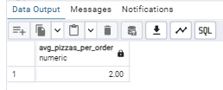

**B. Daily Trend for Total Orders**

select to_char(order_date,'day'),count(distinct order_id)

from pizza_sales

group by 1

***Output:***

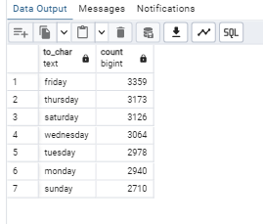

**C. Monthly Trend for Orders**

select to_char(order_date,'month'),count(distinct order_id)

from pizza_sales

group by 1

***Output***

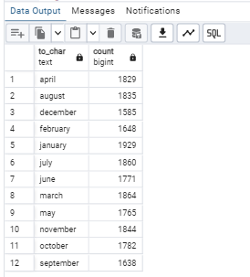

**D. % of Sales by Pizza Category**

select pizza_category,sum(total_price) as total_revenue,

round((sum(total_price)*100 / (select sum(total_price) from pizza_sales)),2) as percentage

from pizza_sales

group by 1

***Output***

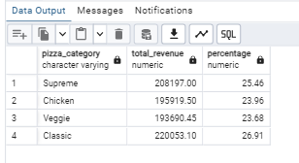

**E. % of Sales by Pizza Size**

select pizza_size,sum(total_price) as total_revenue,

round((sum(total_price)*100 / (select sum(total_price) from pizza_sales)),2) as percentage

from pizza_sales

group by 1

***Output***

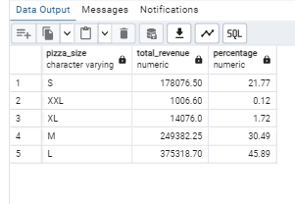

**F. Total Pizzas Sold by Pizza Category**

select pizza_category, sum( quantity) as total_pizzas,

round((sum( quantity)*100 / (select sum( quantity) from pizza_sales)),3) as percentage

from pizza_sales

group by 1

***Output***

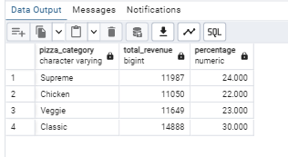

**G. Top 5 Pizzas by Revenue**

select pizza_name,sum(total_price) as revenue

from pizza_sales

group by pizza_name

order by 2 desc

limit 5

***Output :***

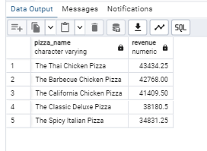

**H. Bottom 5 Pizzas by Revenue**

select pizza_name,sum(total_price) as revenue

from pizza_sales

group by pizza_name

order by 2

limit 5

***Output***

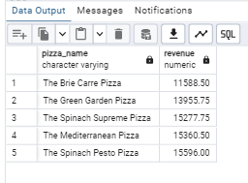

**I. Top 5 Pizzas by Quantity**

select pizza_name,sum(quantity) as total pizzas

from pizza_sales

group by pizza_name

order by 2 desc

limit 5

***Output***

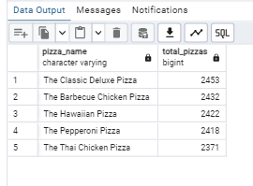

**J. Bottom 5 Pizzas by Quantity**

select pizza_name,sum(quantity) as total_pizzas

from pizza_sales

group by pizza_name

order by 2

limit 5

***Output***

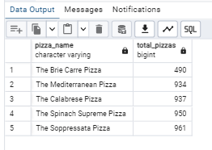

**K. Top 5 Pizzas by Total Orders**

select pizza_name,count( distinct order_id) as total_orders

from pizza_sales

group by pizza_name

order by 2 desc

limit 5

***Output :***

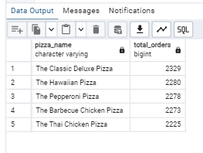

**L. Borrom 5 Pizzas by Total Orders**

select pizza_name,count( distinct order_id) as total_orders

from pizza_sales

group by pizza_name

order by 2

limit 5

***Output :***

